Bus Reservation Details:

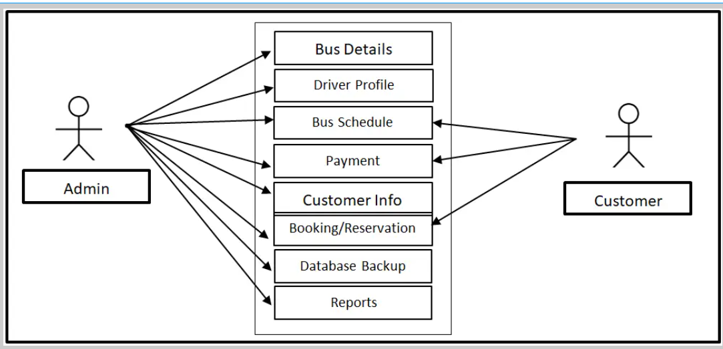

**Bus Details:**

1. As a user, I want to search for bus schedules based on my departure and destination locations, as well as the date of travel, so that I can book my ticket as per my plannings.

Acceptance Criteria:

1. The user should be provided with input fields to enter their departure and destination locations.
2. User should be able to select the data of travel from a calendar or date picker interface.
3. Entering the departure and destination locations, as well as the date of travel, the user should be able to initiate a search for bus schedules.
4. The schedules should include departure times, arrival times, duration of travel, and any intermediates stops or transfers.

**Driver Profile:**

1. As a user, I want to view detailed profiles of drivers including their name, photo, rating, and experience to make an informed decision, so that I can get into the correct bus.

Acceptance Criteria:

1. The driver’s full name must be displayed prominently on the profile page.
2. The driver’s photo must be clearly visible and identification on the profile page.
3. The driver’s overall rating based on feedback from previous passengers must be displayed prominently.
4. User should be able to view detailed feedback and comments provided by previous passengers to understand the driver’s area for improvement.
5. The design of the driver profile page should be user-friendly and intuitive, allowing user to navigate easily and find the information they need.

**Payments:**

1. As a user, I want to be able to select from multiple payment methods, such as credit/debit cards, mobile wallets, or other electronic payment options, to accommodate my preferences and convenience, so that I can do my payments easily in any of the way.

Acceptance criteria:

1. The system should support multiple payments methods such as credit/debit cards, mobile wallets, and other electronics payments options.
2. After completing the payment, users should be redirected to a confirmation page.
3. User should have the option to save their payment information securely for future bookings.
4. User should receive a confirmation email or SMS containing details of their booking and payments.

Customer Info:

1. As a user, I want the ability to update my personal information (such as name, address, and contact details) so that my account reflects accurate and current information.

Acceptance Criteria:

1. When the user navigates to the "Account Settings" or a similar section, there should be a clear option to edit personal information.
2. The user should be able to edit the following personal information fields: name, address, and contact details.
3. Changes to the personal information fields should be validated to ensure they meet any specified criteria.
4. After making changes, there should be a "Save" or "Update" button that the user can click to apply the changes.
5. Upon successfully saving the changes, a confirmation message should be displayed, clearly indicating that the personal information has been updated.